Wiring

The G90 can use a 13.8V external DC power supply. The DC power supply has a current load capacity of at least 10A. The supplied power cord can be used to connect radio and DC power.
When connecting the DC power supply, please carefully connect according to the following figure to avoid reverse polarity of the power supply.

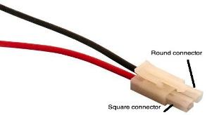

The red wire is connected to the positive pole (Square connector) of the power supply, and the black wire is connected to the negative pole of the power supply (Round Connector).
Warning: Connecting the power connections in the reverse order can Severely Damage your radio!

When using an external DC power supply, you must prevent external interference from entering the radio through the power line or that the radio frequency is radiated outside through the power line, we can put an EMC magnetic ring (not supplied) on the power line. Install the magnetic ring as close as possible to the radio.
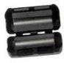
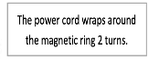

When using an external power supply, carefully check the polarity of the power cord and do not reverse the polarity.

The limited warranty of this radio does not include damage caused by an external power connection error or damage caused by improper power supply voltage.

6.1 Connector Wiring Diagrams

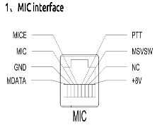

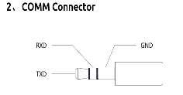
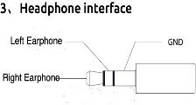

35

